Final Project Group 1
Created a VPC
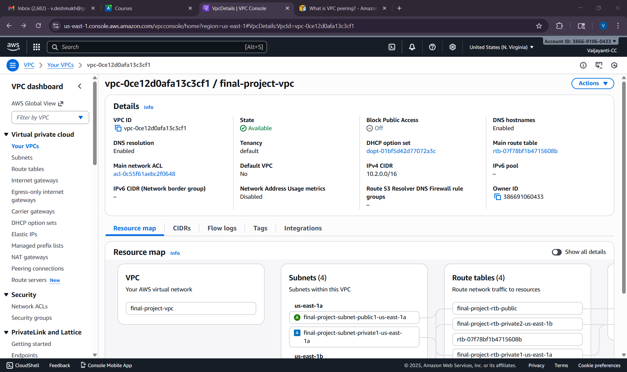
Each one of us used different IP address blocks
Vaijayanti : 10.2.0.0/16
Lasya : 10.1.0.0/16
Josh : 10.0.0.0/16
Vaijayanti : Account ID : 386691060433, VPC ID : vpc-0ce12d0afa13c3cf1
Josh : Account ID: 776781950279, VPC ID: vpc-093ba73512d874061
Lasya : Account ID: 989367328520, VPC ID: vpc-0498016f2d63dfbf8
Creating a VPC Connection
Lasya sent a request
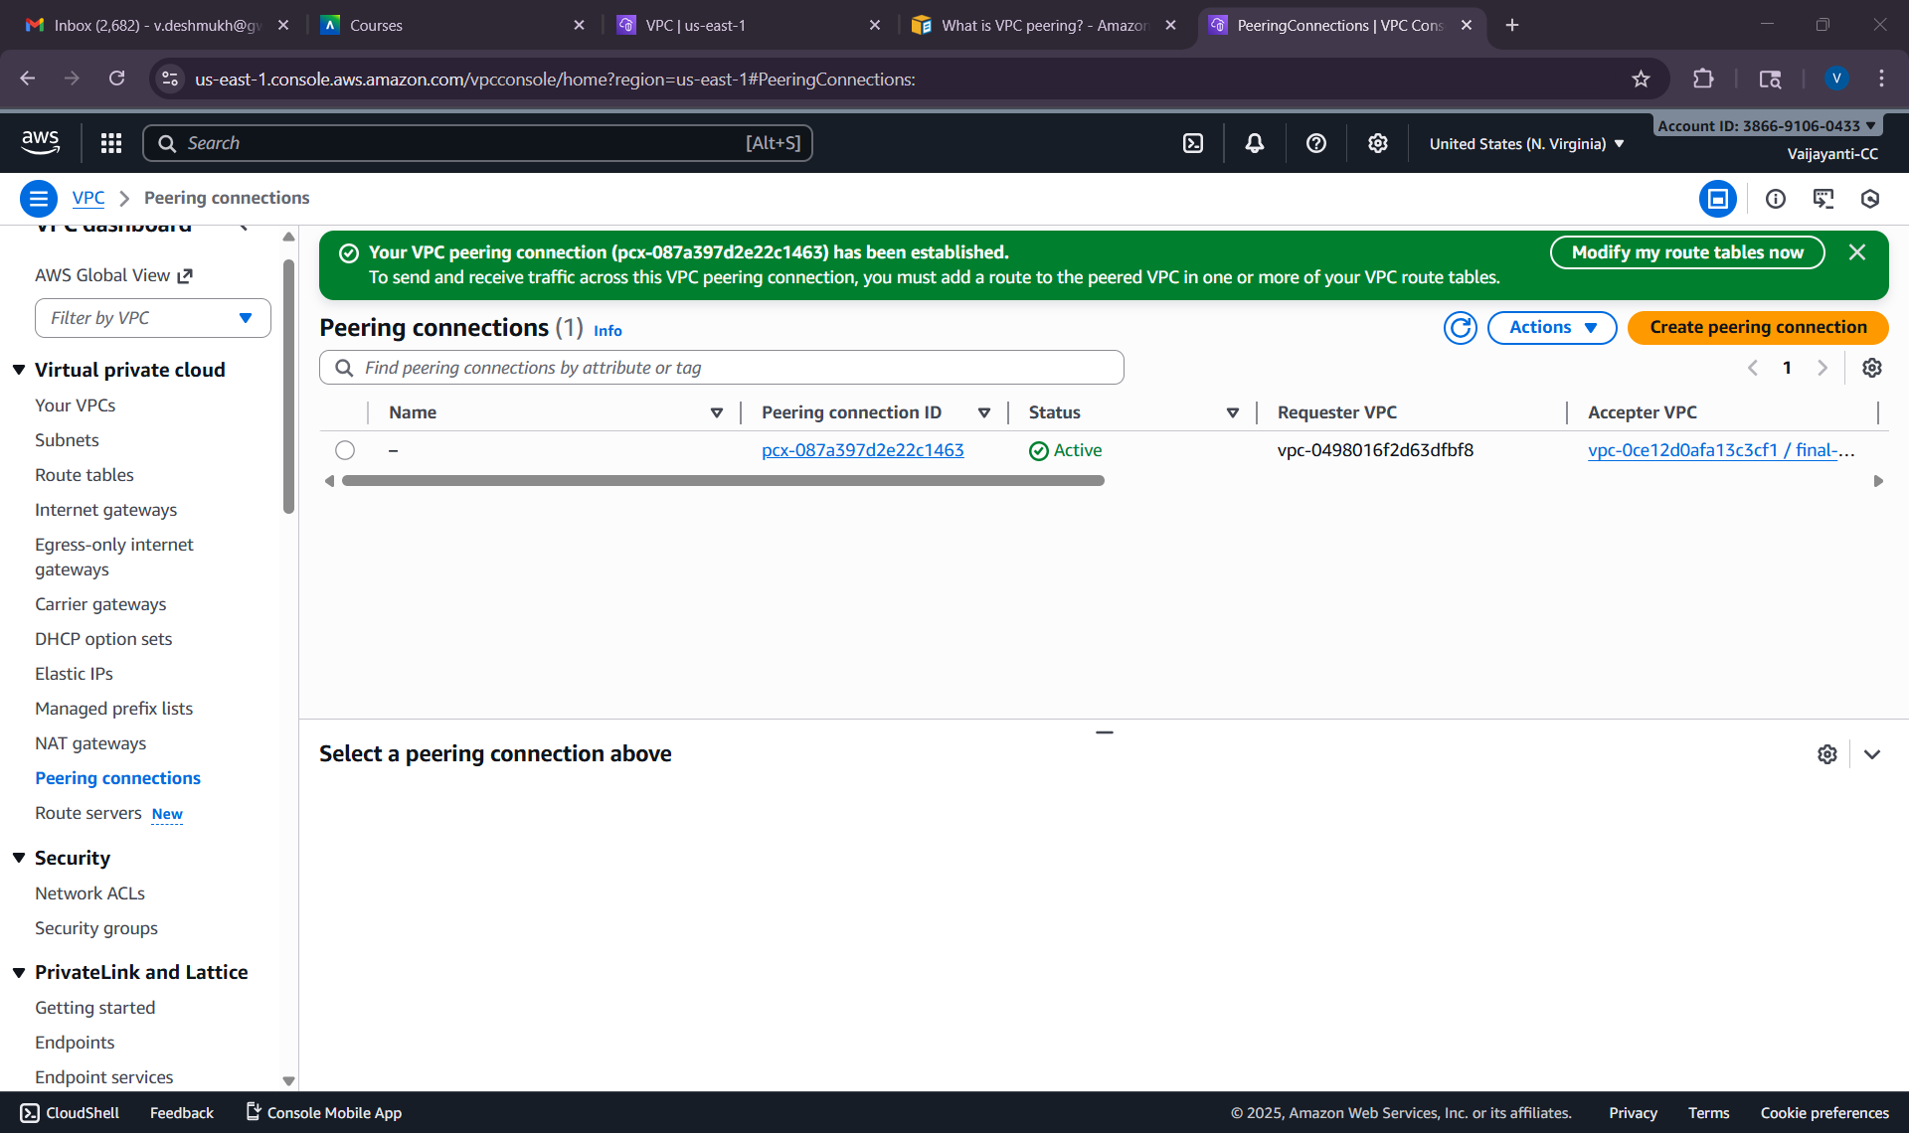
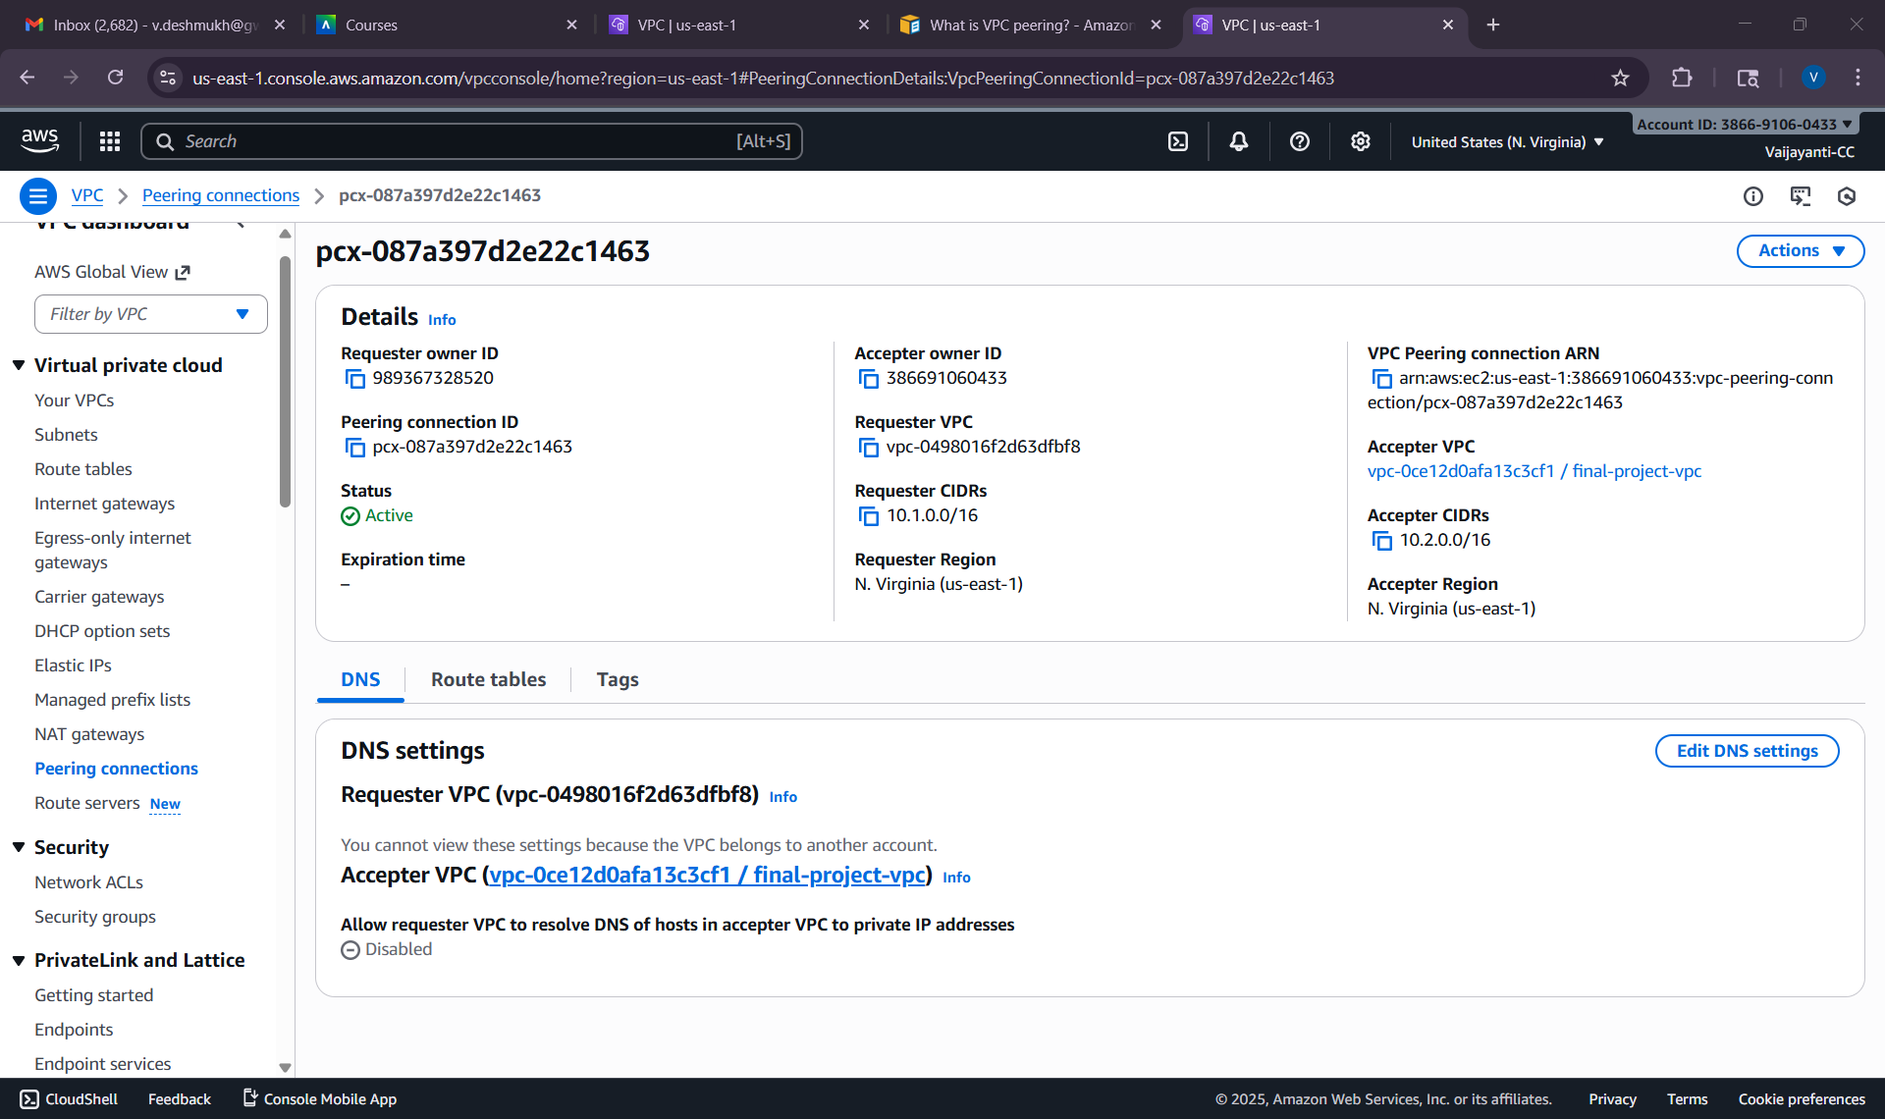
I am sending a request to Josh
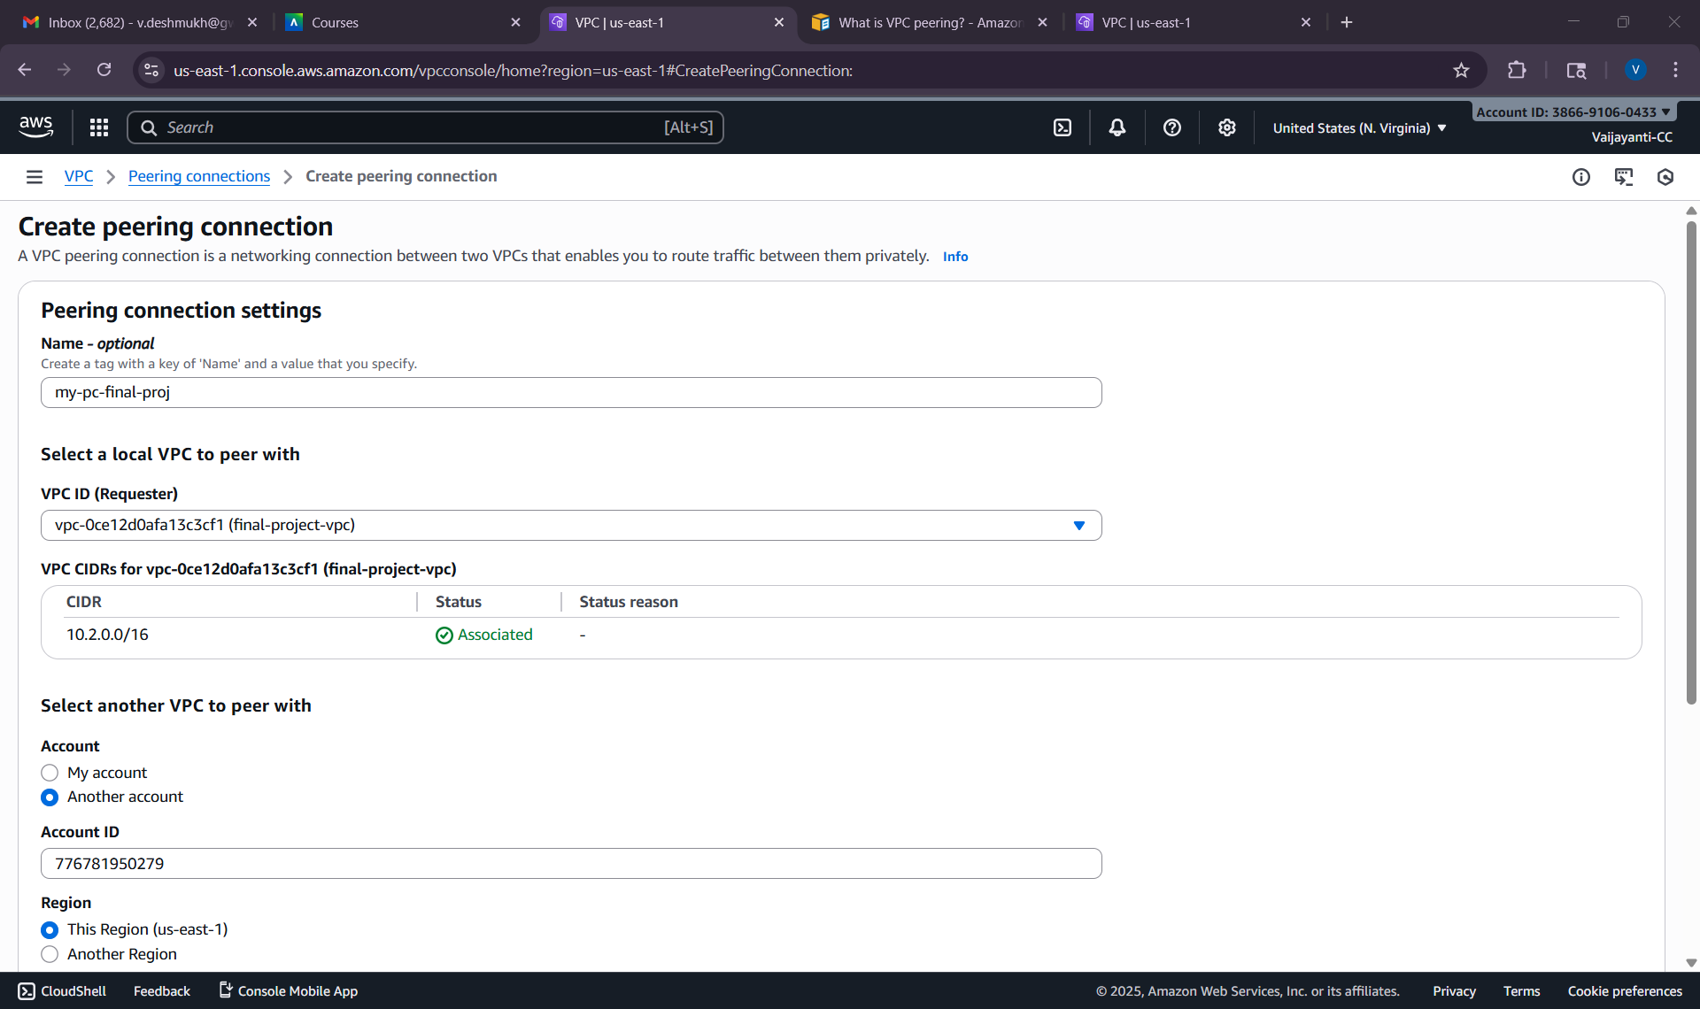
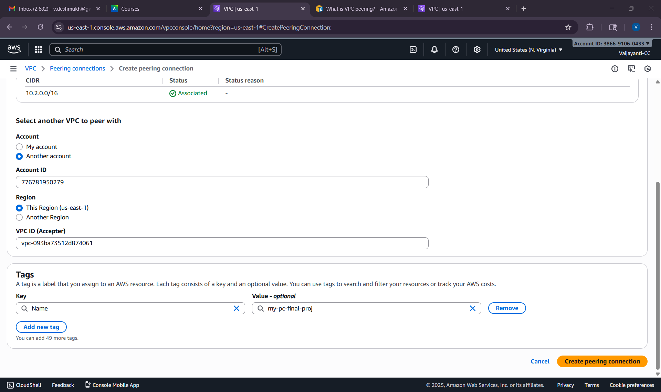
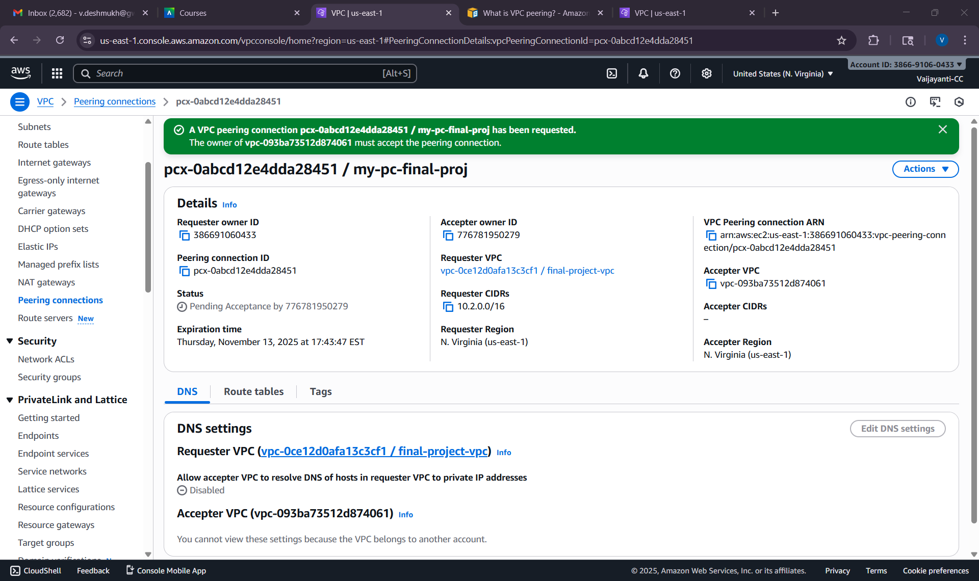
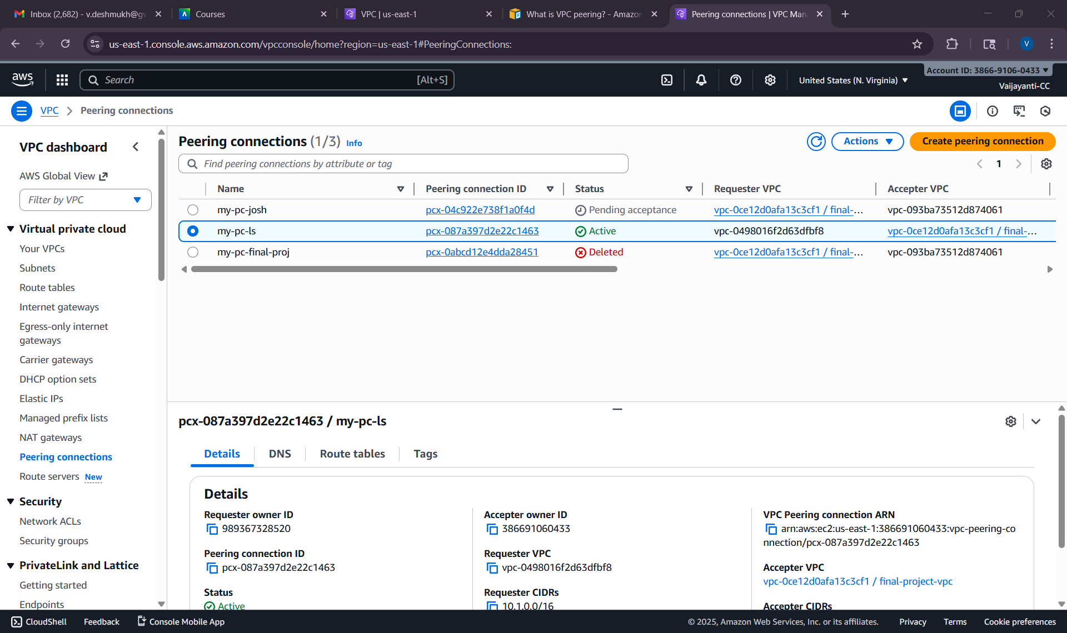
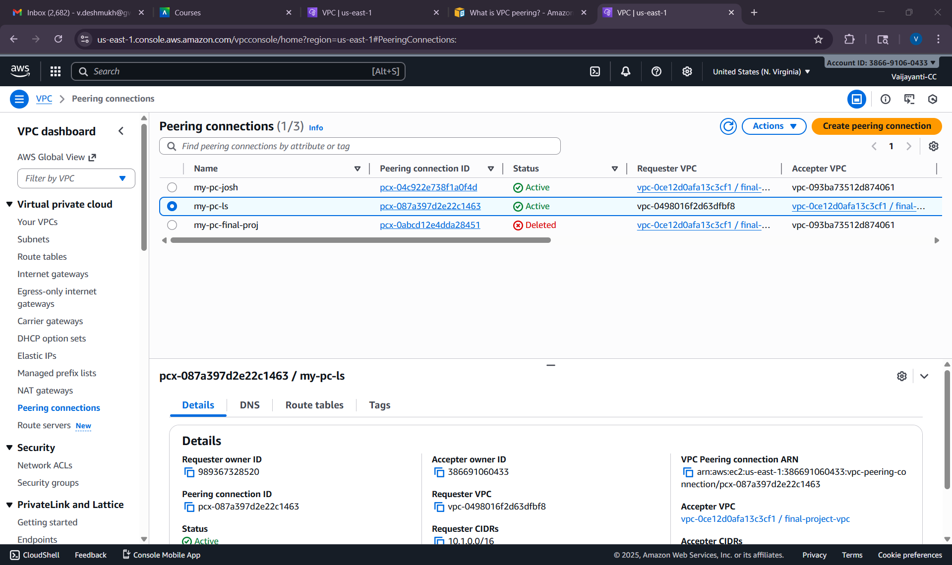
Peering Connections formed :
- Lasya to Josh and vice versa
- Vaijayanti to Josh & vice versa
- Lasya to Vaijayanti & vice versa
Next, we create routing tables
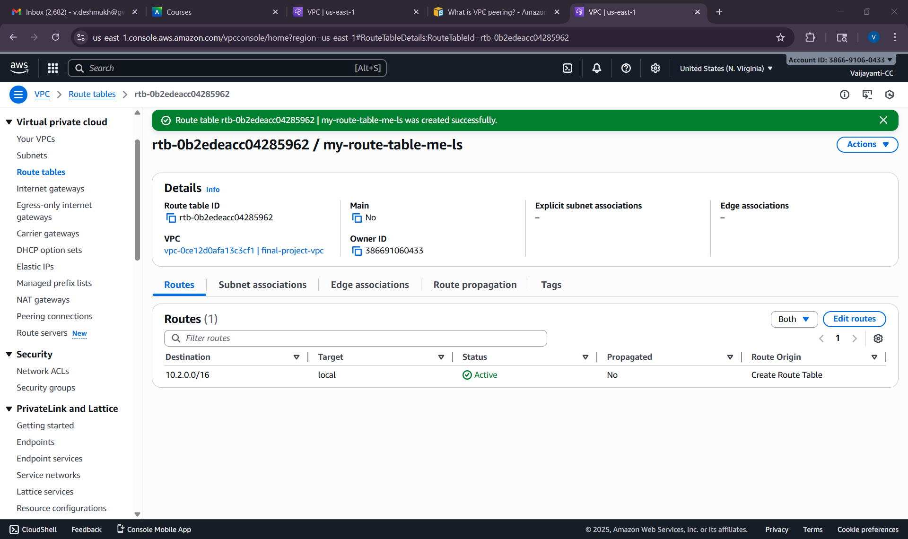
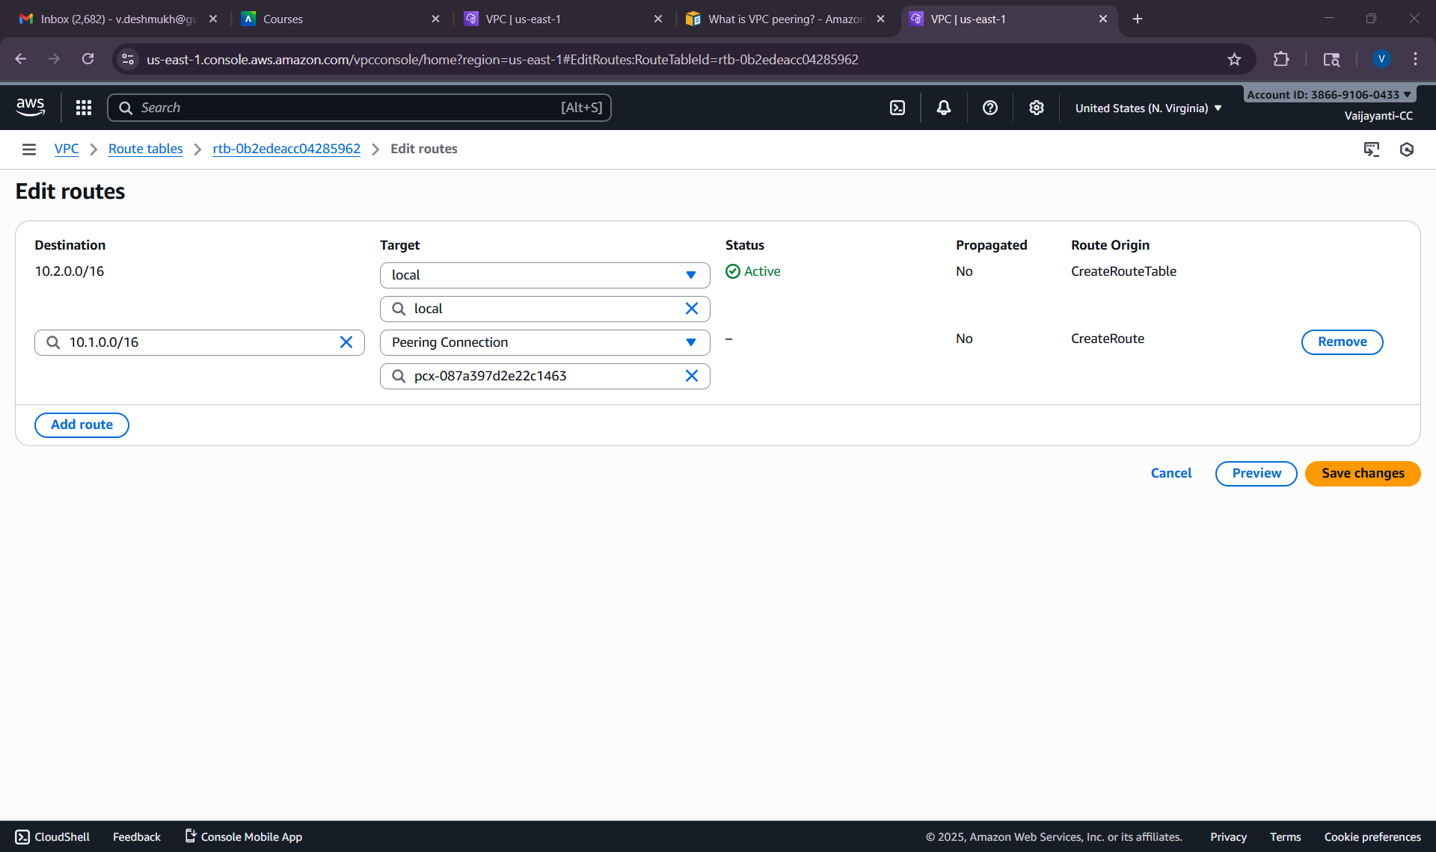
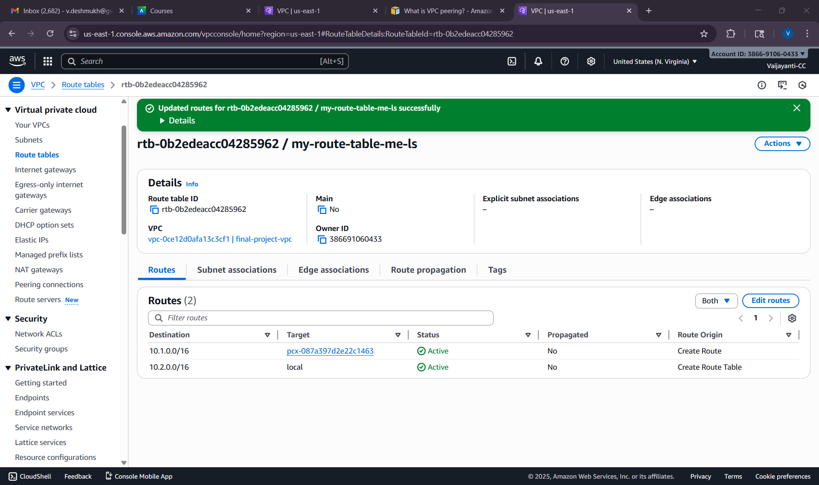
Creating one with Josh
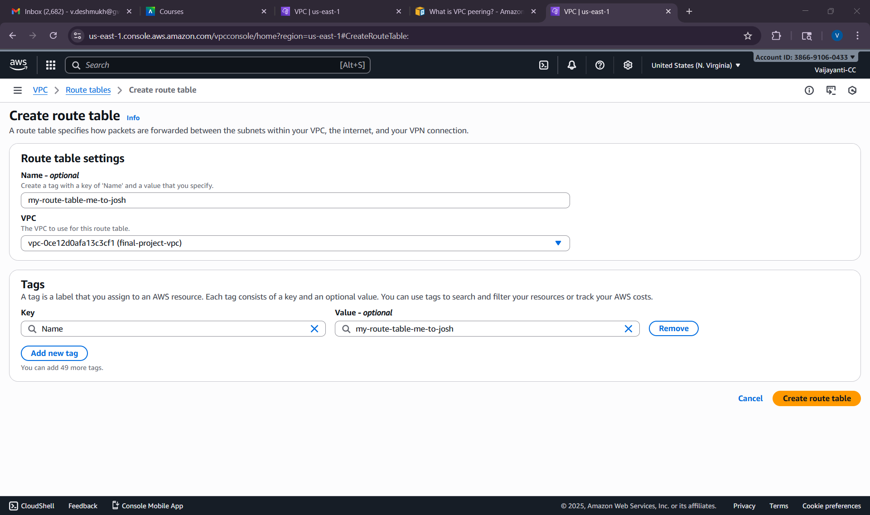
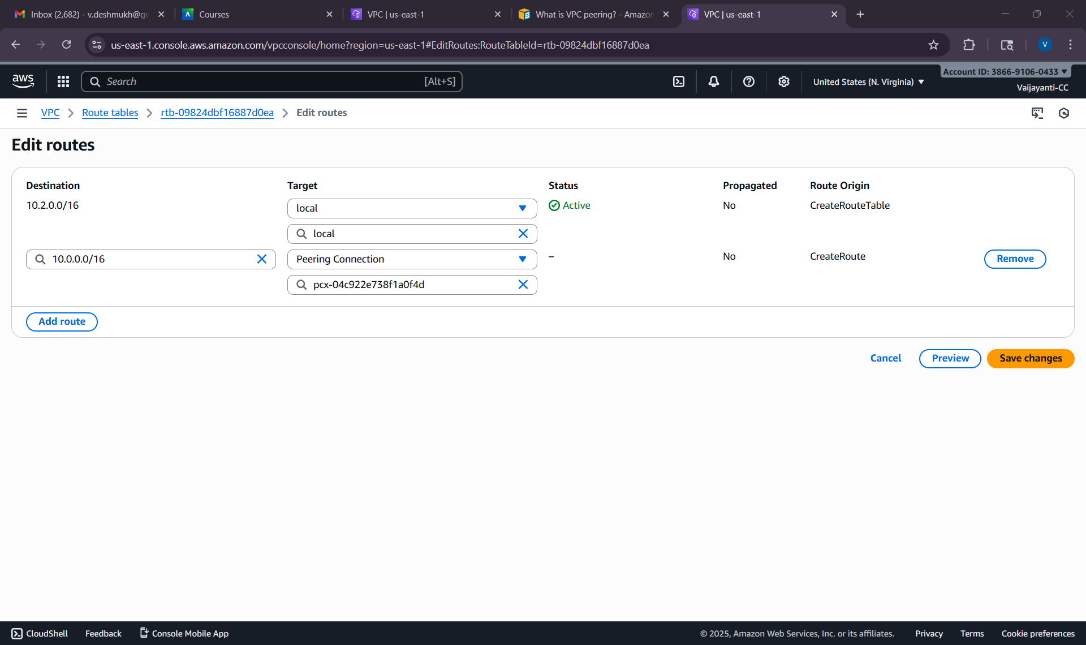
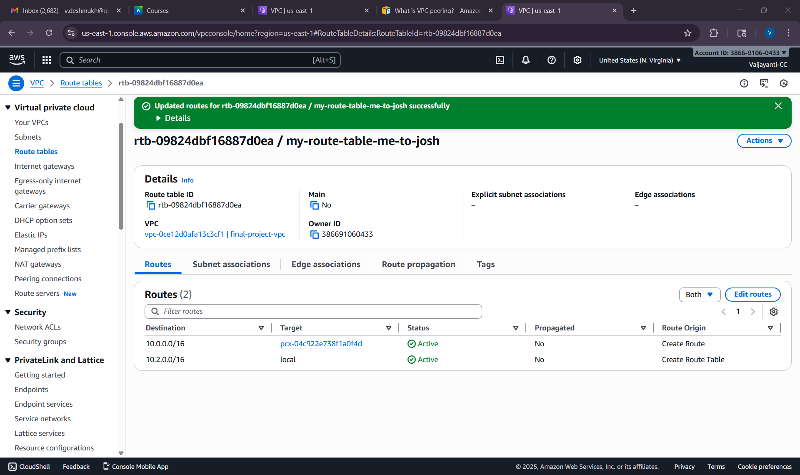
creating EC2 instances on our individual accounts and launching it in private subnets
